CONTENTS

**CHAPTER 1** 10-20

1.Introduction 11

1.1Climate change 11

1.2 Greenhouse effect 12

1.3 Greenhouse gases 13

1.4 Impact of CO2 on the climate change 13

1.5 Impact of CH4 on the climate change 15

1.6 Methods for mitigation the GHG emission 15

1.7 Reforming reactions of methane

1.7.1

1.7.2

1.7.3

1.7.4

1.7.4.1

1.8 Aims and objectives of the dissertation 17

**CHAPTER 2** 21-31

Literature Review

**CHAPTER 3**

Experimental

3.1 preparation of catalysts

3.2 Reaction procedure

3.3 Characterization of catalysts

3.3.1. Powder X-ray diffraction analysis

3.3.2. BET

3.3.3. Gas chromatography

3.3.4 Temperature Programmed reduction (TPR)

3.3.5 CHNS analysis

**Chapter 4**

Results and Discussions

4.1 X-ray diffraction

4.2 Temperature programmed reduction

4.3 BET

4.4 C H N S

4.5Activity data

**Chapter 4**

Conclusions

5.1 Summary of the report

5.2 Future scope

**1.Introduction**

**1.1Climate change**

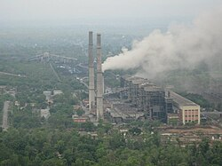**C**limate change is the phrase used to describe long-term changes in regional and worldwide weather patterns that are mostly caused by rises in **greenhouse gas emissions** from human activities such as burning fossil fuels. Changes in a region's typical weather patterns over time are referred to as climate change. Earth's temperature has been sharply increasing for a long time. Local climates throughout the world are being impacted by this trend. In 2019, India came in at number seven on the list of nations most impacted by climate change. In comparison to the global average, India emits fewer greenhouse gases annually—roughly 3 gigatonnes (Gt) CO2eq, or 2.5 tonnes per person. Despite having 17% of the world's population, the nation contributes 7% of global emissions. India's climate change performance index places it ninth out of 63 nations that will be responsible for 92% of global greenhouse gas emissions in 2021. The **Gangas, Brahmaputra, Yamuna**, and other important rivers' flow rates are in danger due to the retreat of Himalayan glaciers brought on by temperature increases on the Tibetan Plateau. The Indus River might dry up for the same reason, according to a 2007 **World Wide Fund for Nature (WWF)** assessment. In places like Assam, severe landslides and floods are predicted to occur more frequently. Climate warming is making heat waves more frequent and intense in India. Between 1901 and 2018, India's temperatures increased by 0.7 °C (1.3 °F) between 1901 and 2018.

Increased flooding, intense heat, a shortage of food and water, an increase in illness, and financial loss are all threats posed by climate change. Conflict and human migration may potentially follow. According to the **World Health Organisation (WHO)**, one of the greatest risks to world health in the twenty-first century is climate change. If nothing is done to curb warming, societies and ecosystems will face greater threats. The effects of climate change on the environment are becoming more significant. Wildfires and heat waves are increasing, and deserts are spreading. Sea ice decrease, glacier retreat, and permafrost thawing have all been exacerbated by increased warming in the Arctic. Storms, droughts, and other weather extremes are becoming more severe due to rising temperatures. Many species are being forced to move or go extinct due to the rapid environmental change occurring in the Arctic, mountains, and coral reefs. Some consequences will last for generations even if attempts to reduce future warming are successful. Sea level rise, ocean acidification, and ocean heating are some of them.

Climate change encompasses a broad range of impacts beyond just rising temperatures, including:

* Changes in temperature and precipitation patterns.
* Rising sea levels and ocean acidification.
* Melting glaciers and sea ice.
* Increased frequency and intensity of extreme weather events (droughts, floods, storms, wildfires).
* Shifts in ecosystem characteristics, like altered growing seasons and migration pattern

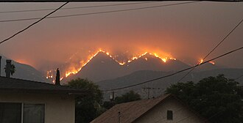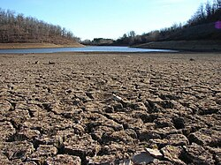

***Figure represents some consequences of climate change which includes increased heat and drought-induced wildfires, increased coral bleaching from marine heatwaves, and severe droughts that jeopardise water supply.***

**1.2 Greenhouse effect**

The planet naturally warms as a result of gases in the atmosphere trapping solar heat that would otherwise escape into space. This phenomenon is known as the **greenhouse effect**. The Earth's atmosphere retains heat through a natural mechanism known as the "greenhouse effect," which makes the planet warm enough to sustain life. Heat is trapped in the lower atmosphere by some gases, referred to as greenhouse gases, which absorb infrared radiation from the Earth's surface and re-emit it in all directions. This mechanism keeps the Earth from getting too cold, much like a greenhouse does. One of the biggest threats to humanity is climate change. 195 nations reached an agreement at the United Nations Climate Change Conference in Paris at the end of last year to decrease   
CO2 and other greenhouse gas emissions, with the goal of keeping the rise in global temperatures well below 2.8C (compared to the pre-industrial climate, which means a future warming of less than 1.4 8C because the temperature had already risen by 0.6 8C by the end of the 20th century). Through the well-known "greenhouse effect," Radiation from the sun heats the Earth's surface as it travels through the atmosphere mainly unimpeded. The atmosphere, which serves as a blanket around the Earth, absorbs a large portion of the energy that is subsequently reemitted as infrared. A natural greenhouse effect would cause the average surface temperature to drop to around 21.8C,1 rath. Our lives depend heavily on fossil fuels. They are extensively employed in the production of power and in transportation. Carbon dioxide is released when fossil fuels are burned. Burning fossil fuels increases the amount of CO2 in the atmosphere each year, warming the earth and intensifying the natural greenhouse effect. Therefore, The Quantitative responses to this query are offered by the projections of intricate Earth System Models (ESMs). These models, which are executed on supercomputers, combine the many processes occurring in the ocean, on land, and in the atmosphere The use of fossil fuels has expanded in tandem with population growth. As a result, the amount of greenhouse gases released into the environment has increased. Earth's average temperature rises as a result of rising greenhouse gas concentrations. This directly connects the greenhouse effect to global warming, which causes ice caps to melt, sea levels to rise, and extreme weather events to occur more frequently. Although mainly linked to CFCs, the general increase in greenhouse gases can also affect the ozone layer indirectly. A thinner ozone layer allows more harmful UV rays to reach the surface, posing health risks like skin cancer. When gases such as nitrogen oxides and sulphur oxides mix with sunlight and other chemicals, smog can form. This affects air quality and visibility, and it is more common in industrial or densely populated areas. Excess carbon dioxide dissolves in oceans, forming carbonic acid. This lowers the pH of water bodies and harms marine life. On land, acidic pollutants can combine with rain to form acid 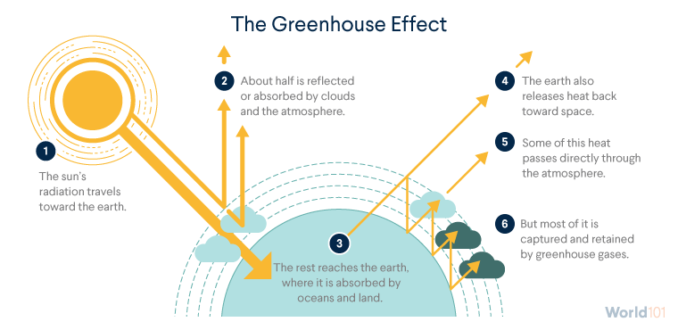rain, which damages crops, forests, and aquatic ecosystems

Figure no 2

The average world temperature is rising as a result of additional heat being trapped by the increased quantities of greenhouse gases, particularly carbon dioxide (CO2). The amount of CO2 in our atmosphere has been between 200 and 280 parts per million for the majority of the last 800,000 years, which is a lot longer than human civilisation has existed. (To put it another way, there were 200–280 gas molecules for every million air molecules.) However, that concentration has increased during the last century. In 2013, the amount of CO2 in the earth's atmosphere exceeded 400 parts per million, a quantity not seen in millions of years, mostly due to the combustion of fossil fuels and deforestation. It has risen to around 420 parts per million as of 2023. which is half of what it was before the industrial revolution.

**1.2 Greenhouse gases**

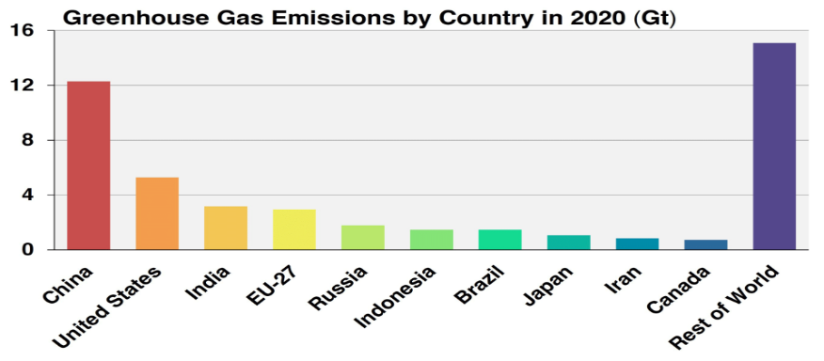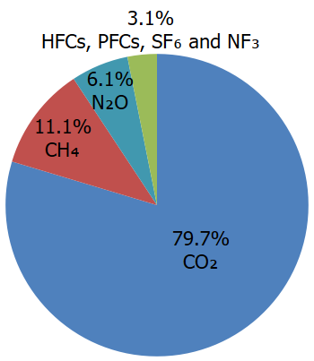Greenhouse gases (GHGs) are a category of gases that absorb heat energy emitted from the planet's surface and they remain in Earth's atmosphere for a long time (from decades to centuries). Though they make up only a small portion of the atmosphere (less than 1% of all air molecules), GHGs absorb a significant amount of heat energy and re-radiate some of it back toward the surface. They're called "Greenhouse gases" Greenhouse gases are gases that retain heat in the atmosphere. Burning fossil fuels (coal, natural gas, and oil), solid waste, trees, and other biological materials, as well as some chemical processes (such the making of cement), release carbon dioxide into the atmosphere. When plants absorb carbon dioxide as part of the biological carbon cycle, it is taken out of the atmosphere (or "sequestered"). Coal, natural gas, and oil production and transportation all release methane. Land usage, livestock and other agricultural activities, and the decomposition of organic waste in municipal solid waste dumps are other sources of methane emissions. Nitrous oxide is released during solid waste and fossil fuel burning, industrial, land use, and agricultural processes, as well as during wastewater treatment. Synthetic, potent greenhouse gases, such as **hydrofluorocarbons, perfluorocarbons, sulphur hexafluoride, and nitrogen trifluoride,** are released from a range of commercial, industrial, and residential uses and operations. Sometimes, fluorinated gases—particularly hydrofluorocarbons—are employed in place of compounds that deplete the ozone layer in the stratosphere, such as hydrochlorofluorocarbons, halons, and chlorofluorocarbons. Although they are powerful greenhouse gases, fluorinated gases are usually released in lesser amounts than other greenhouse gases. They are frequently called high-GWP gases because, for a given mass, they trap significantly more heat than CO2, with **global warming potentials (GWPs)** that usually vary from thousands to tens of thousands.

Figure1

China, the United States, India, the European Union, Russia, Indonesia, Brazil, Japan, Iran, and Canada were the top ten countries in 2020 for greenhouse gas emissions. These figures include emissions of CO2, CH4, N2O, and fluorinated gases from garbage, industry, forestry, energy, and land use change. About 67% of all greenhouse gas emissions in 2020 will come from these top 10 nations combined.

**1.4 Impact of CO2 on the climate change**

Carbon dioxide (CO2) is one of the greenhouse gases that cause global warming, rising atmospheric CO2 levels have become a major environmental concern in recent years. Deforestation, agricultural activities, and the burning of fossil fuels for energy production are the main causes of the rise in atmospheric CO2 concentration implementing efforts to reduce CO2 emissions into the atmosphere is essential to protecting the earth for future generations. The amount of CO2 in the atmosphere is known to have changed significantly as a result of the Industrial Revolution. The extensive use of fossil fuels, such as coal and oil, for energy production during this period led to a substantial increase in CO2 emissions into the atmosphere. The increased industrial production and transportation also resulted in the deforestation of vast areas of forest, further exacerbating the issue these emissions have caused a sustained increase in the concentration of CO2 in the atmosphere, leading to the current state of global warming and climate change. Climate change represents one of the most pressing challenges facing the global community in the 21st century. At the heart of this phenomenon lies the significant and sustained increase in atmospheric concentrations of greenhouse gases, particularly carbon dioxide (CO₂). CO₂ is the most prevalent an human-generated greenhouse gas, accounting for approximately three-quarters of total global emissions. Its role in climate change is both direct and profound, as it contributes substantially to the enhanced greenhouse effect a process in which heat energy radiated from Earth's surface is trapped by greenhouse gases, preventing it from escaping into space and thereby warming the planet. Prior to the Industrial Revolution, CO₂ levels remained relatively stable at around 280 parts per million (ppm). However, rapid industrialization and the large-scale combustion of fossil fuels—coal, oil, and natural gas—have driven CO₂ levels to exceed 420 ppm as of 2024, marking the highest concentration in at least 800,000 years (NASA, 2024). This unprecedented increase has led to a significant rise in global average temperatures, with the planet currently warming at a rate of approximately 0.2°C per decade. The Intergovernmental Panel on Climate Change (IPCC) has unequivocally stated that the primary driver of recent global warming is the accumulation of greenhouse gases—chief among them, CO₂—due to human activity. The consequences of rising CO₂ levels and the associated climate changes are already evident. These include the intensification of extreme weather events (e.g., hurricanes, droughts, and heatwaves), accelerated melting of polar ice and glaciers, rising sea levels, shifting climate zones, and disruption of marine and terrestrial ecosystems. Moreover, CO₂ also contributes to ocean acidification, as it dissolves into seawater and forms carbonic acid, negatively affecting marine biodiversity, particularly organisms with calcium carbonate shells such as corals and molluscs CO₂ is particularly problematic due to its long atmospheric lifetime. Unlike other short-lived climate pollutants (such as methane), CO₂ can persist in the atmosphere for hundreds to thousands of years, making the climate impacts essentially irreversible on human timescales. As a result, urgent mitigation strategies are required to reduce emissions, enhance carbon sinks through reforestation and soil management, and transition to low-carbon energy systems. International climate frameworks, including the 2015 Paris Agreement, underscore the importance of limiting global warming to well below 2°C, preferably 1.5°C, which is only achievable through significant reductions in CO₂ emissions. In sum, carbon dioxide plays a pivotal role in the current climate crisis. Understanding its sources, mechanisms of action, and long-term effects is essential for crafting effective policies, technological solutions, and adaptive strategies.

These include:

* **Polar ice melt** and **glacial retreat**, contributing to rising sea levels.
* **Thermal expansion of oceans**, which further increases sea levels and affects coastal communities.
* **Ocean acidification**, as CO₂ dissolves in seawater and forms carbonic acid, threatening marine ecosystems.
* **Disruption of weather patterns**, with more frequent and intense events like heatwaves, droughts, floods, and hurricanes.
* **Shifts in ecosystems and biodiversity loss**, as species struggle to adapt to rapidly changing climates.

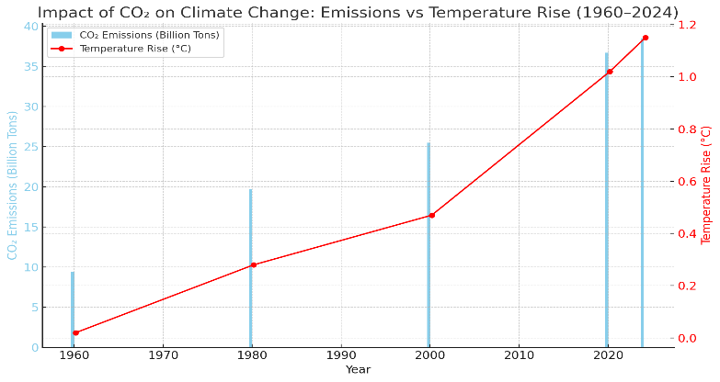

***Figure bar graph showing CO₂ emissions and global temperature rise from 1960 to 2024***

**1.5 Impact of CH4 on the climate change**

Methane (CH₄) is the second most significant anthropogenic GHG after carbon dioxide (CO₂), but it has a far stronger short-term capacity to trap heat. Despite being present in the atmosphere in much lower concentrations than CO₂, methane has a much higher global warming potential (GWP) than CO₂, with the IPCC reporting that it is about 84–86 times more potent over a 20-year period and 28–34 times more potent over a 100-year period. When paired with increasing emission rates, this increased potency makes CH₄ a crucial target for mitigation methods against climate change. Heat is successfully trapped in the atmosphere by methane's absorption of terrestrial infrared light. Methane has a comparatively short atmospheric lifetime of around 12 years, in contrast to CO₂, which stays in the atmosphere for hundreds of years. But its warming effect is far more pronounced during this little time. Methane's molecular structure, which makes it extremely effective at absorbing infrared light, accounts for its potency as a GHG. The Global Methane Budget (2020) estimates that anthropogenic sources account for over 60% of the world's annual methane emissions, which amount about 570 million metric tons. Methane concentrations in the atmosphere have more than doubled from the pre-industrial era, rising from about 700 parts per billion (ppb) to over 1900 ppb today. Since 2007, emissions have increased extremely quickly, and since 2014, they have increased especially sharply. Increased extraction of fossil fuels, particularly shale gas, intensification of agriculture, and modifications to the dynamics of tropical wetlands are perhaps 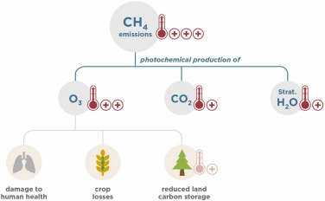some of the contributing factors.

Figure

**1.6 Methods for mitigation the GHG emission**

Mitigating greenhouse gas (GHG) emissions is crucial in addressing climate change, and several strategies can be employed to reduce emissions across various sectors. One of the most effective methods is the transition to renewable energy sources, such as solar, wind, and hydro power. By replacing fossil fuels with clean energy, emissions from the power generation sector, which is one of the largest sources of CO₂, can be drastically reduced. This transition is key to decarbonizing the global energy grid and preventing further warming. Another essential approach is improving **energy efficiency** across industries, buildings, and transportation. By using energy more efficiently, we reduce the overall demand for energy, thereby cutting emissions associated with energy production. Implementing measures like better insulation, more efficient appliances, and optimized industrial processes can significantly lower energy consumption and reduce GHG emissions. This method not only helps decrease emissions but also leads to cost savings for businesses and households. Carbon capture and storage (CCS) technologies present another promising solution for mitigating emissions, particularly from heavy industries and power plants. CCS involves capturing CO₂ emissions at their source and storing them underground or using them in other applications, such as concrete production. While still in development, this technology allows for continued use of fossil fuels without directly contributing to atmospheric CO₂ accumulation. However, scaling up CCS faces challenges related to cost and infrastructure. In the **agriculture sector**, sustainable farming practices play a critical role in reducing methane (CH₄) and nitrous oxide (N₂O) emissions. Implementing techniques like improving livestock feed to reduce methane emissions, optimizing fertilizer use to minimize N₂O release, and adopting no-till farming methods can help cut emissions. Agriculture is a major source of GHGs, especially methane from livestock and rice paddies, so these changes can have a significant impact on overall emissions. Additionally, **reforestation and afforestation** are vital methods for absorbing CO₂ from the atmosphere. By planting trees or restoring degraded forests, we enhance the planet's capacity to act as a carbon sink. Forests naturally absorb CO₂ through photosynthesis, and expanding forest cover can significantly help mitigate climate change by removing carbon from the air. Forest management is thus an important strategy in both long-term and short-term climate action. **Electrification of transportation** is another critical strategy, as the transportation sector is a major contributor to GHG emissions, especially from gasoline- and diesel-powered vehicles. Switching to electric vehicles (EVs) and improving public transportation infrastructure can significantly reduce emissions, particularly if the electricity used is generated from renewable sources. This transition is necessary for achieving global emission reduction targets.To tackle emissions from waste, **waste reduction and recycling** play a pivotal role. Landfills are a significant source of methane, as organic waste decomposes anaerobically. By reducing waste generation, recycling more materials, and composting organic waste, we can prevent methane emissions from landfills. Moreover, recycling materials like plastics, metals, and paper reduces the need for new production, thereby conserving energy and reducing emissions. Another effective strategy is **carbon pricing**, which includes mechanisms such as carbon taxes and cap-and-trade systems. Carbon pricing helps internalize the environmental cost of emissions, encouraging businesses and individuals to adopt cleaner practices and invest in low-carbon technologies. By placing a price on carbon, carbon pricing provides a strong financial incentive to reduce emissions and invest in sustainable practices.The development of **alternative fuels and biofuels** also offers a pathway to emission reductions, especially in sectors like transportation and industry. Biofuels, derived from organic materials, can replace conventional fossil fuels and help cut emissions. When produced sustainably, biofuels produce fewer GHGs than fossil fuels, contributing to a reduction in emissions from the energy and transportation sectors. Finally, **behavioural and lifestyle changes** at the individual and societal levels can complement these mitigation strategies. Encouraging changes such as adopting plant-based diets, reducing energy consumption, and using low-carbon transportation options can have a significant impact on overall emissions. Though individual actions may seem small, when practiced collectively on a large scale, they can make a meaningful contribution to emission reductions.

Mitigating greenhouse gas (GHG) emissions is crucial in addressing climate change, and several strategies can be employed to reduce emissions across various sectors. One of the most effective methods is the transition to renewable energy sources, such as solar, wind, and hydro power. By replacing fossil fuels with clean energy, emissions from the power generation sector, which is one of the largest sources of CO₂, can be drastically reduced. This transition is key to decarbonizing the global energy grid and preventing further warming. Another essential approach is improving **energy efficiency** across industries, buildings, and transportation. By using energy more efficiently, we reduce the overall demand for energy, thereby cutting emissions associated with energy production. Implementing measures like better insulation, more efficient appliances, and optimized industrial processes can significantly lower energy consumption and reduce GHG emissions. This method not only helps decrease emissions but also leads to cost savings for businesses and households. Carbon capture and storage (CCS) technologies present another promising solution for mitigating emissions, particularly from heavy industries and power plants. CCS involves capturing CO₂ emissions at their source and storing them underground or using them in other applications, such as concrete production. While still in development, this technology allows for continued use of fossil fuels without directly contributing to atmospheric CO₂ accumulation. However, scaling up CCS faces challenges related to cost and infrastructure. In the **agriculture sector**, sustainable farming practices play a critical role in reducing methane (CH₄) and nitrous oxide (N₂O) emissions. Implementing techniques like improving livestock feed to reduce methane emissions, optimizing fertilizer use to minimize N₂O release, and adopting no-till farming methods can help cut emissions. Agriculture is a major source of GHGs, especially methane from livestock and rice paddies, so these changes can have a significant impact on overall emissions. Additionally, **reforestation and afforestation** are vital methods for absorbing CO₂ from the atmosphere. By planting trees or restoring degraded forests, we enhance the planet's capacity to act as a carbon sink. Forests naturally absorb CO₂ through photosynthesis, and expanding forest cover can significantly help mitigate climate change by removing carbon from the air. Forest management is thus an important strategy in both long-term and short-term climate action. **Electrification of transportation** is another critical strategy, as the transportation sector is a major contributor to GHG emissions, especially from gasoline- and diesel-powered vehicles. Switching to electric vehicles (EVs) and improving public transportation infrastructure can significantly reduce emissions, particularly if the electricity used is generated from renewable sources. This transition is necessary for achieving global emission reduction targets.To tackle emissions from waste, **waste reduction and recycling** play a pivotal role. Landfills are a significant source of methane, as organic waste decomposes anaerobically. By reducing waste generation, recycling more materials, and composting organic waste, we can prevent methane emissions from landfills. Moreover, recycling materials like plastics, metals, and paper reduces the need for new production, thereby conserving energy and reducing emissions. Another effective strategy is **carbon pricing**, which includes mechanisms such as carbon taxes and cap-and-trade systems. Carbon pricing helps internalize the environmental cost of emissions, encouraging businesses and individuals to adopt cleaner practices and invest in low-carbon technologies. By placing a price on carbon, carbon pricing provides a strong financial incentive to reduce emissions and invest in sustainable practices. The development of **alternative fuels and biofuels** also offers a pathway to emission reductions, especially in sectors like transportation and industry. Biofuels, derived from organic materials, can replace conventional fossil fuels and help cut emissions. When produced sustainably, biofuels produce fewer GHGs than fossil fuels, contributing to a reduction in emissions from the energy and transportation sectors. Finally, **behavioural and lifestyle changes** at the individual and societal levels can complement these mitigation strategies. Encouraging changes such as adopting plant-based diets, reducing energy consumption, and using low-carbon transportation options can have a significant impact on overall emissions. Though individual actions may seem small, when practiced collectively on a large scale, 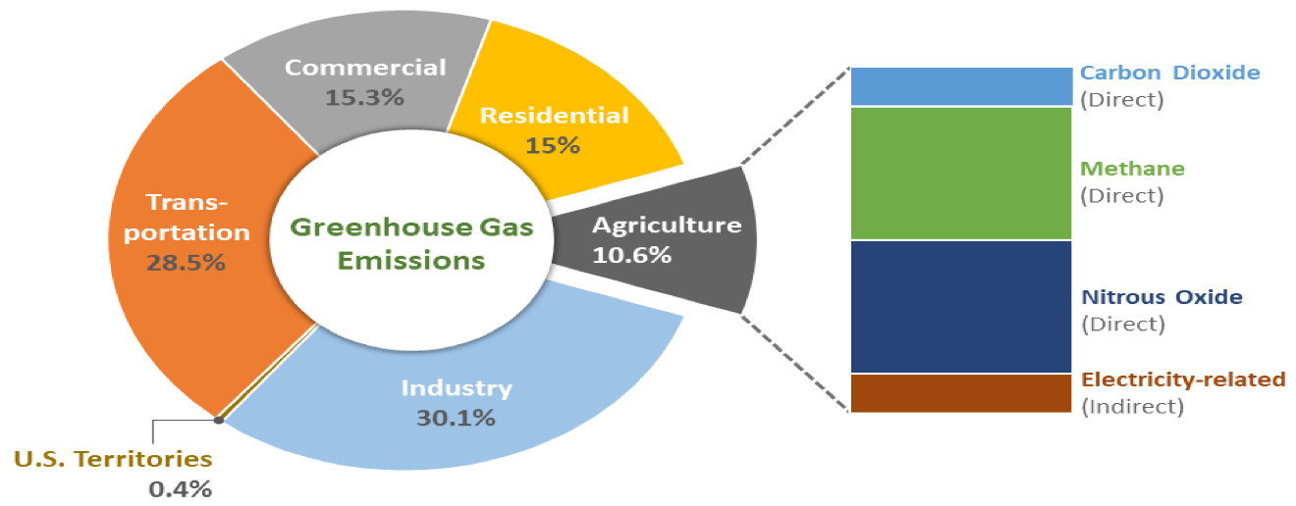they can make a meaningful contribution to emission reductions

**1.6 Reforming reactions of methane**

**Reforming reactions of methane** are chemical processes used primarily to convert methane (CH₄), the main component of natural gas, into syngas (a mixture of hydrogen and carbon monoxide), which can then be used to produce fuels, chemicals, or hydrogen gas. These reactions are crucial in industrial hydrogen production and are being studied for cleaner energy technologies. The major reforming methods include:

**1.6.1. Steam reforming of methane (SRM)**

Steam reforming of methane is a commonly employed technique for generating syngas, a mixture of hydrogen and carbon monoxide. The process entails the reaction of methane (CH4) with steam (H2O) at elevated temperatures in the presence of a catalyst. The primary chemical reaction for steam reforming of methane is shown in equation 1.1. In this reaction, one methane molecule reacts with one steam molecule to yield one carbon monoxide molecule and three hydrogen molecules. This endothermic reaction requires high temperatures, typically ranging from 700 to 1000 °C. SRM encounters notable drawbacks, including a substantial energy demand, a high H2/CO product ratio, and inadequate selectivity for carbon monoxide

**Reaction**:

CH4 + H2O → CO + 3H2  (ΔH=+206 kJ/mol) 1.1

**1.6.2. Partial oxidation of methane (POM)**

Partial oxidation of methane is another method used to produce syngas by reacting methane (CH4) with oxygen (O2). This process occurs at high temperatures and can be either catalytic or non-catalytic. The chemical reaction for partial oxidation of methane is represented in equation 1.2

**Reaction:**

CH4​ + ½O2 ​→ CO + 2H2  ( ​ΔH=−36kJ/mol ) 1.2

It is a better option compared to steam reforming due to its greater selectivity for syngas production, exothermic nature, and more desirable H2/CO ratio. Partial oxidation of methane has also presents several challenges. Non-catalytic partial oxidation requires operation at extremely high temperatures, which can be impractical. The use of group VIII metal-based catalysts can mitigate this by lowering the necessary reaction temperature. However, even a slight decrease in CO selectivity can cause a significant increase in reaction temperature. At high methane conversion and space velocities, this process generates substantial heat within a confined catalyst zone, leading to the formation of hot spots, especially in large reactors, complicating temperature control. Moreover, when nickel is used as a catalyst, it tends to deactivate rapidly due to carbon deposition, further hindering the process's efficiency and longevity

**1.6.3. Dry reforming of methane (DRM)**

In steam reforming and partial oxidation, only methane is used to produce syngas, whereas dry reforming of methane utilizes both CH4 and CO2 to generate syngas [36–38]. The process of producing syngas by chemically reacting carbon dioxide with methane is referred to as dry reformation of methane. The reaction can be represented in equation.1.3

**Reaction:**

CH4 + CO2 **→**  2CO + 2H2 (∆H°= 247 kJ/mole) 1.3

The reaction is highly endothermic, requiring significant energy input to maintain the high temperatures necessary for the process. Catalysts utilized in DRM are susceptible to deactivation caused by carbon deposition (coking), which reduces their effectiveness over time. DRM typically produces a lower yield of syngas compared to other methods, such as steam reforming or partial oxidation.

**1.6.4. Bi-reforming of methane (BRM)**

The combination of steam and dry reforming of methane is known as bi-reforming of methane. The BRM reaction is displayed in equation 1.4

**Reaction:**

CH4 + CO2 + 2H2O **→**  4CO + 8H2 (∆H°= 220 kJ/mole) 1.4

The bi-reforming of methane, has been gaining huge attention from academics and industries as a promising process for syngas production as it overcomes all the disadvantages with the existing SRM, POM, and DRM methods. BRM is a hybrid process of SRM and DRM, which uses both steam and CO2 for CH4 reforming. BRM seems to be a promising option for syngas production due to its specific advantages of greenhouse gas utilization, flexibility in adjusting the H2/CO ratio by optimizing feed, and high stability due to the coexistent H2O and CO2 as a superior oxidizing agent.

| **Method** | **Reactants** | **Products** | **Temperature** | **Energy Type** | **H₂/CO Ratio** |
| --- | --- | --- | --- | --- | --- |
| **SMR** | CH₄ + H₂O | CO + 3H₂ | 700–1000°C | Endothermic | ~3:1 |
| **DRM** | CH₄ + CO₂ | 2CO + 2H₂ | 700–900°C | Endothermic | ~1:1 |
| **POM** | CH₄ + ½O₂ | CO + 2H₂ | 800–1000°C | Exothermic | ~2:1 |
| **BRM** | CH₄ + CO₂ + H₂O | 3CO + 5H₂ | 700–900°C | Endothermic | ~1.6:1 |

**1.6.4.1 The reactions involved in bi-reforming of methane**

3CH4 + CO2 + 2H2O → 4CO + 8H2 (∆H°= 220 kJ/mole) Bi-reforming

CH4 + H2O → CO + 3H2 (∆H°= 206 kJ/mole) Steam reforming

CH4 + CO2→ 2CO + 2H2 (∆H°= 247 kJ/mole) Dry reforming

CO + H2O↔ CO2+ H2 (∆H°= -41 kJ/mole) WGS reaction

CO2+ H2 ↔ CO + H2O (∆H°= 41 kJ/mole) RWGS reaction

CH4 → C + 2H2 (∆H°= 75 kJ/mole) Methane decomposition

2CO → C + CO2 (∆H°= -172 kJ/mole) Boudourd reaction

C + H2O → CO + H2 (∆H°= 131 kJ/mole) Coke gasification reaction

C + CO2 → 2CO (∆H°= 172 kJ/mole) Coke gasification reaction

**1.8 Aims and objectives of the dissertation**

**The aims and objectives of the thesis are as follows.**

Development and production of Ni supported on perovskite and mixed oxide catalysts that can be used to bi-reform methane with CO2.

Being aware of how mixed metal oxides promote catalysts that contain nickel.

Investigating the characteristics of Ni on various supports and their function in BRM.

Determine the alterations linked to the catalyst's pre-reduction in order to forecast the type of active species and the impact of activity.

connecting the BRM activity of the Ni-based catalysts supported on mixed oxides with their surface-structural characteristics.

To comprehend how base metals and nickel behave in perovskite catalysts.

To achieve high activity in the BRM, optimize the reaction conditions.

Examining catalytic stability and determining the causes of both deactivation and high stability.

**Experimental**

**3.1 preparation of catalysts**

The catalysts were made using the **deposition-precipitation** technique.

**3.1.1 Deposition–precipitation (DP) method**

The deposition–precipitation (DP) method is a widely used and effective technique for the synthesis of supported metal catalysts, particularly when high metal dispersion and strong metal–support interactions are desired. It involves the controlled precipitation of metal hydroxide species from a metal salt solution directly onto the surface of an oxide support, such as γ-Al₂O₃, under specific pH and temperature conditions. This technique is especially advantageous for preparing catalysts like nickel-based systems, where uniform distribution and nanoscale particle size are critical for catalytic performance in applications such as methane reforming, hydrogen production, and CO₂ conversion. The DP method offers better control over particle growth compared to traditional methods like impregnation, leading to improved catalytic activity, selectivity, and thermal stability.

**3.2.4. Drying**

In this process, the solvent—typically water—is extracted from the support's pores. For crystalline solids, this is a standard procedure; however, flocculates and hydro gels, which contain up to 90% water, make it crucial. In certain situations, the texture may collapse when the water is removed, therefore if high porosity is wanted, drying must be carefully managed. The drying condition has no effect on the uniform dispersion of the active component on supports with a comparatively larger adsorption capacity (high porosity). These factors affect both the structure and characteristics of the final catalysts for carriers with poor adsorption capacity (low porosity). To enable uniform redistribution of the active ingredients on the support surface, the rate of evaporation must be gradual and reversible.

**3.2.5. Calcination**

Calcination is a type of heat treatment that goes beyond drying and involves heating without the creation of a liquid phase. It is conducted at temperatures greater than those utilized in the catalytic process in air or inert gas. A number of chemical and physical changes may occur in this step, including the breakdown of the impregnated metal precursor into its corresponding oxides, interactions between the active component and the support, sintering of the support, the creation of solid solutions and perovskites, and the condensation of the support's hydroxyl groups. The catalyst's surface and mechanical characteristics are mostly determined during the calcination process, since it also solidifies into a final shape, such as crystalline from amorphous.

**3.1.1. Deposition–precipitation (DP) method of nickel (Ni) supported on γ-Al₂O₃**

The deposition–precipitation method was employed to synthesize a nickel-supported γ-Al₂O₃ catalyst with precise control over pH and material loading. In this process, **2.257 g of nickel nitrate hexahydrate (Ni(NO₃)₂·6H₂O)** and **2.778 g of γ-Al₂O₃** were accurately weighed and added to a **100 mL beaker**. Deionized water was then added to bring the total solution volume to **25 mL**, forming a sky-blue-coloured suspension under continuous stirring. To initiate the precipitation of nickel hydroxide onto the γ-Al₂O₃ surface, **5% aqueous ammonia solution** was added dropwise while monitoring the pH. It required **17 mL of ammonia** solution to gradually raise the pH to **8-9**, Then checked whether any precipitate is forming or not and ensuring that precipitation occurred directly on the support rather than in the bulk solution. The pH-adjusted mixture was then transferred to an oven and aged **overnight at approximately 100 °C**, allowing complete deposition and adherence of Ni species onto the support. The next morning, the pH was found to have stabilized at **7**, indicating equilibrium in the system. The precipitated material was then filtered and washed thoroughly with deionized water **three times** to remove residual nitrate and ammonium ions. Vacuum filtration was used to efficiently remove water from the solid product. Following filtration, the washed material was **dried overnight at 100–120 °C** in an oven. The dried catalyst precursor was subsequently **calcined at 800 °C for 4 hours** in a muffle furnace at a ramp rate of approximately **5 °C/min**. This calcination step converted nickel hydroxide to nickel oxide (Nio), yielding a fine, light sky-blue coloured powder with nickel species well-dispersed on the γ-Al₂O₃ support. The prepared catalysts (3/6/9/12/15 wt%) name denoted as **3%Ni/ γ-Al₂O₃, 6% Ni/ γ-Al₂O₃,9% Ni/ γ-Al₂O₃,12% Ni/ γ-Al₂O₃,15% Ni/ γ-Al₂O₃.**